# CS 255 System Design Document Template

This template lays out all the different sections that you need to complete for Project Two. Each section has guidance to prompt your thinking. You will need to continually reference the interview transcript as you work to make sure that you are addressing your client’s needs. There is no required length for the final document. Instead the goal is to complete each section based on what your client’s needs are. Remove this note when you are finished, and replace all bracketed text with the relevant information.

## UML Diagrams

### UML Use Case Diagram

### UML Activity Diagrams

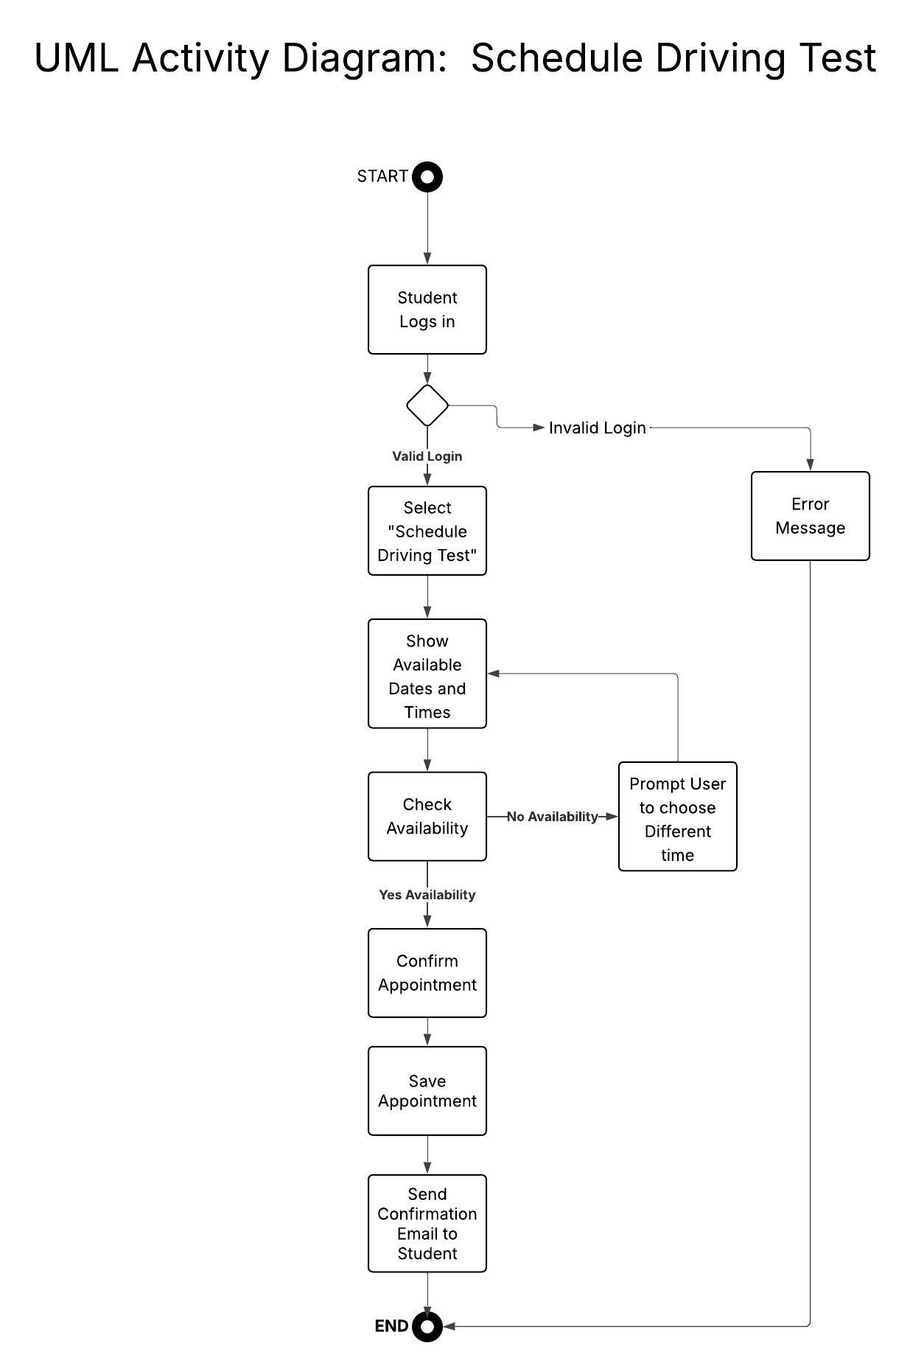

### UML Sequence Diagram

### UML Class Diagram

## Technical Requirements

I would recommend using MYSQL to manage complex relationships

between these entities. The application will be built with a web server using JavaScript for the

front end and either Java or Python for the backend. Personally, I would choose Python. As far as

development tools are concerned; I would use Visual Studio code and GIT for version control.

With the system being cloud based it will assist with the infrastructure being scalable for its

storage. It will require regular backups to ensure data security and availability